INSTITUTIONAL PROGRAM REVIEW 2009-10
Program Efficacy Phase, Spring, 2010

Purpose of Institutional Program Review

Welcome to the Program Efficacy phase of the San Bernardino Valley College Program Review process. Program Review is a systematic process for evaluating programs and services annually. The major goal of the Program Review Committee is to evaluate the effectiveness of programs, and to make informed decisions about budget and other campus priorities.

The Institutional Program Review Committee is authorized by the Academic Senate to develop and monitor the college Program Review process, receive unit plans, utilize assessments as needed to evaluate programs, recommend program status to the college president, identify the need for faculty and instructional equipment, and interface with other college committees to ensure institutional priorities are met.

The purpose of Program Review is to:
❑ Provide a full examination of how effectively programs and services are meeting departmental, divisional, and institutional goals
❑ Aid in short-range planning and decision-making
❑ Improve performance, services, and programs
❑ Contribute to long-range planning
❑ Contribute information and recommendations to other college processes, as appropriate
❑ Serve as the campus’ conduit for decision-making by forwarding information to or requesting information from appropriate committees

Our Program Review process is two-fold. It includes an annual campus-wide needs assessment in the fall, and an in-depth review of each program every three years that we call the Program Efficacy phase. Instructional programs are evaluated the year after content review, and every three years thereafter, and other programs are placed on a three-year cycle by the appropriate Vice President.

An efficacy team of two disinterested committee members will meeting with you to carefully review and discuss your document. You will receive detailed feedback regarding the degree to which your program is perceived to meet institutional goals. The rubric that the team will use to evaluate your program is included with this e-mail

When you are writing your program evaluation, you may contact efficacy team assigned to review your department or your division representatives for feedback and input. The list of readers is being sent to you with these forms as a separate attachment.

Forms are due back to the Committee Chairs, Efficacy Team and Division Dean by March 22, 2010.
It is the writer’s responsibility to be sure the Committee receives the forms on time.

In response to campus wide feedback that program review be a more interactive process, the committee will pilot a program efficacy that includes a review team who will interviews and/or tour a program area during the efficacy process. Another campus concern focused on the duplication of information required for campus reports. The pilot will incorporate the Educational Master Plan One-Page Summary (EMP Summary) and strive to reduce duplication of information while maintaining a high quality efficacy process. More details on the pilot can be found in the attached file.

Program Efficacy, Spring 2010

Complete and attach this cover sheet as the first page of your report.

Program Being Evaluated
Inspection Technology

Name of Department:
Inspection Technology

Name of Division
Applied Technology, Transportation and Culinary Arts

Name of Person Preparing this Report Extension
Bill Kastner

Name of Department Members Consulted
Click here to enter text.

Name of Efficacy Team
Jose Recinos Ext. 8607; Denise Knight Ext. 8547

Program Review Committee Representatives
Guy Hinrichs; Richard Jaramillo

Work Flow | Due Date | Date Submitted
Date of initial meeting with department | Click here to enter text. | Click here to enter text.
Final draft sent to the dean | Click here to enter text. | Click here to enter text.
Report submitted to Program Review Team | Click here to enter text. | Click here to enter text.
Meeting with Review Team | Click here to enter text. | Click here to enter text.

Staffing
List the number of full and part-time employees in your area.
Classification | Number Full-Time | Number Part-time, Contract | Number adjunct, short-term, hourly
Managers | Click here to enter text. | Click here to enter text. | Click here to enter text.
Faculty | Click here to enter text. | Click here to enter text. | Click here to enter text.
Classified Staff | Click here to enter text. | Click here to enter text. | Click here to enter text.
Total | Click here to enter text. | Click here to enter text. | Click here to enter text.

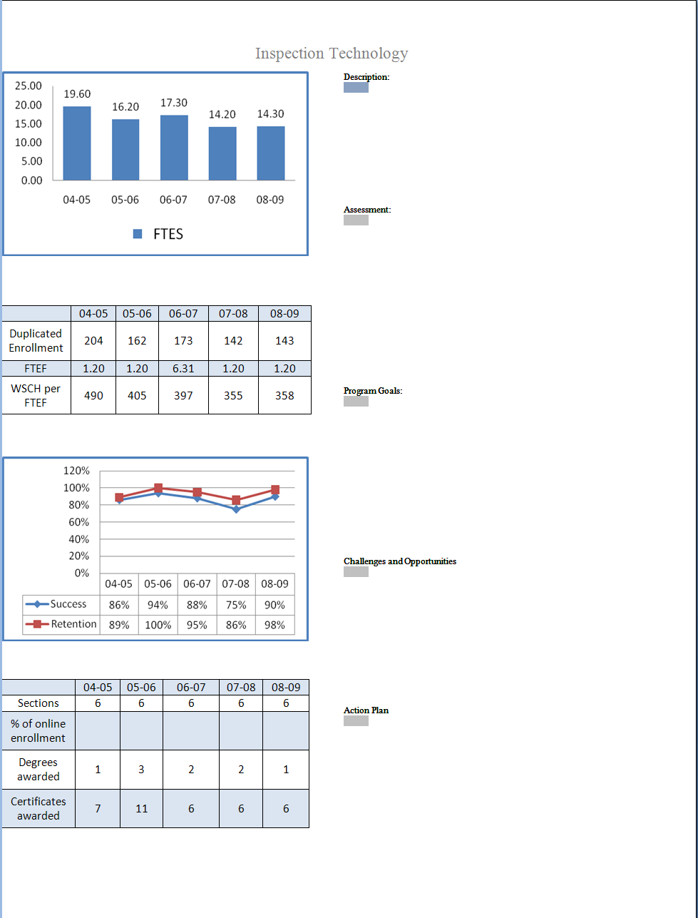
Part I. Questions Related to Strategic Initiative: Access

Use the demographic data provided to describe how well you are providing access to your program by answering the questions below.

Gender | Frequency | Dept. Pct. | Campus Pct.
Female | 51 | 10.1% | 58.5%
Male | 449 | 89.3% | 40.5%
Total | 503 | 100.0%
*Totals do not include respondents who did not identify gender.

Ethnicity | Frequency | Dept. Pct. | Campus Pct.
Blank | 0 | 0% | 1.47%
Asian | 0 | 0% | 4.58%
Black | 32 | 6.4% | 22.03%
Filipino | 1 | .2% | 1.93%
Hispanic | 186 | 37.0% | 39.85%
Nat Amer | 2 | .4% | .99%
Other | 2 | .4% | 1.18%
Pac Islander | 1 | .2% | .75%
White | 266 | 52.9% | 24.55%
X-undeclared | 13 | 2.6% | 3.17%
Total | 503 | 100.0% | 100.00%

Disability | Frequency | Dept. Pct. | Campus Pct.
Non-Disabled | 475 | 94.4% | 95.5%
Disabled | 28 | 5.6% | 4.5%
Total | 503 | 100.0% | 100%

Does the program population reflect the college’s population? Is this an issue of concern? If not, why not? If so, what steps are you taking to address the issue?

Click here to enter text.

Pattern of Service
How does the pattern of service and/or instruction provided by your department serve the needs of the community? Include as appropriate hours of operation/pattern of scheduling, alternate delivery methods, weekend instruction/service.

Click here to enter text.

Part II: Questions Related to Strategic Initiative: Student Success
Provide a brief analysis of the data and narrative from the program’s EMP Summary and discuss what it reveals about your program.
Click here to enter text.
Supplemental Data
Provide any additional information such as job market indicators, standards in the field or licensure rates that would help the committee to better understand how your program contributes to the success of your students.
Click here to enter text.

Student Learning Outcomes
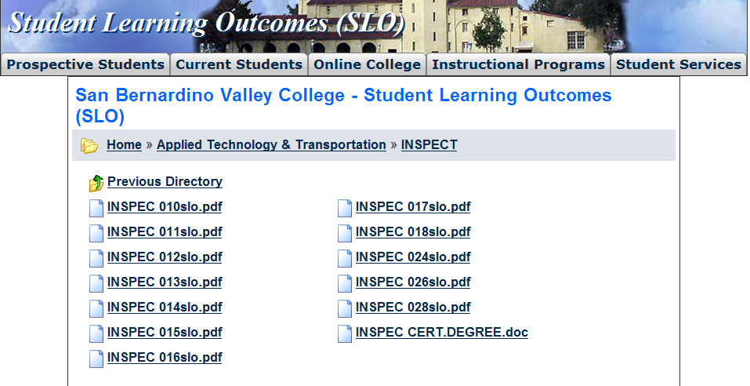
The list above shows the courses that have SLOs on file with the Office of Instruction.

If you have courses for which SLOs have not been developed, explain why. What are your plans to remedy this?
Click here to enter text.

Attach your three-year plan for assessing SLOs.

What progress has the program made in its three-year plan? Have you implemented any program changes based on assessment results?

Part III. Questions Related to Strategic Initiative: Institutional Effectiveness
Mission and Purpose
What is the purpose of the program?

Click here to enter text.

How does this purpose relate to the college mission?

Click here to enter text.

Productivity
Provide additional analysis and explanation of the productivity data and narrative in the EMP Summary, if needed.
Click here to enter text.

Relevance and Currency, Articulation of Curriculum
If applicable to your area, describe your curriculum by answering the following questions.
Applied Technology, Transportation & Culinary Arts
Inspection Technology
 | Course | Status | Last Content Review | Next Review Date
 | INSPEC010A Fundamentals of Construction Inspection I | Historical | 11/15/2005 | 11/15/2011
 | INSPEC010B Fundamentals of Construction Inspection I: Soils | Active | 11/09/2009 | 11/09/2015
 | INSPEC010B Fundamentals of Construction Inspection I: Soils | Historical | 01/11/2008 | 01/11/2014
 | INSPEC011B Fundamentals of Construction Inspection II: Concrete & Asphalt | Historical | 11/15/2005 | 11/15/2011
 | INSPEC011B Fundamentals of Construction Inspection II: Concrete and Asphalt | Active | 11/09/2009 | 11/09/2015
 | INSPEC011B Fundamentals of Construction Inspection II: Concrete and Asphalt | Historical | 01/11/2008 | 01/11/2014
 | INSPEC012A Fundamentals of Construction Inspection III | Historical | 11/15/2005 | 11/15/2011
 | INSPEC012B Fundamentals of Construction Inspection III: Wood, Steel, Masonry | Active | 11/09/2009 | 11/09/2015
 | INSPEC012B Fundamentals of Construction Inspection III: Wood, Steel, Masonry | Historical | 01/11/2008 | 01/11/2014
 | INSPEC013C Advanced Construction Inspection: Uniform Building Code | Historical | 11/15/2005 | 11/15/2011
 | INSPEC013D Advanced Construction Inspection: International Building Code (IBC) | Historical | 01/11/2008 | 01/11/2014
 | INSPEC013D Advanced Construction Inspection: International Building Code (IBC) | Active | 11/09/2009 | 11/09/2015
 | INSPEC014C Advanced Construction Inspection: National Electrical Code | Historical | 11/15/2005 | 11/15/2011
 | INSPEC014C Advanced Construction Inspection: National Electrical Code | Historical | 11/15/2005 | 11/15/2011
 | INSPEC014D Advanced Construction Inspection: National Electrical Code (NEC) | Historical | 01/11/2008 | 01/11/2014
 | INSPEC014D Advanced Construction Inspection: National Electrical Code (NEC) | Active | 11/09/2009 | 11/09/2015
 | INSPEC015C Advanced Construction Inspection: Uniform Plumbing Code | Historical | 11/15/2005 | 11/15/2011
 | INSPEC015D Advanced Construction Inspection: Uniform Plumbing Code (UPC) | Active | 11/09/2009 | 11/09/2015
 | INSPEC015D Advanced Construction Inspection: Uniform Plumbing Code (UPC) | Historical | 01/11/2008 | 01/11/2014
 | INSPEC016C Advanced Construction Inspection: Uniform Mechanical Code | Historical | 11/15/2005 | 11/15/2011
 | INSPEC016D Advanced Construction Inspection: Uniform Mechanical Code (UMC) | Active | 11/09/2009 | 11/09/2015
 | INSPEC016D Advanced Construction Inspection: Uniform Mechanical Code (UMC) | Historical | 01/11/2008 | 01/11/2014
 | INSPEC017C California State Energy Regulations for Residential Buildings | Historical | 11/15/2005 | 11/15/2011
 | INSPEC017D California State Energy Regulations for Residential Buildings | Active | 11/09/2009 | 11/09/2015
 | INSPEC017D California State Energy Regulations for Residential Buildings | Historical | 01/11/2008 | 01/11/2014
 | INSPEC018C California State Energy Regulations for Non-residential Buildings | Historical | 11/15/2005 | 11/15/2011
 | INSPEC018D California State Energy Regulations for Non-residential Buildings | Active | 11/09/2009 | 11/09/2015
 | INSPEC018D California State Energy Regulations for Non-residential Buildings | Historical | 01/11/2008 | 01/11/2014
 | INSPEC024C Community Relations for Civil Service Employees | Historical | 11/15/2005 | 11/15/2011
 | INSPEC024C Community Relations for Civil Service Employees | Historical | 11/15/2005 | 11/15/2011
 | INSPEC024D Community Relations for Civil Service Employees | Active | 11/09/2009 | 11/09/2015
 | INSPEC024D Community Relations for Civil Service Employees | Historical | 01/11/2008 | 01/11/2014
 | INSPEC025C Building Inspection for Civil Service Employees: Communication and Enforcement | Historical | 11/15/2005 | 11/15/2011
 | INSPEC025D Building Inspection for Civil Service Employees: Communication and Enforcement | Active | 11/09/2009 | 11/09/2015
 | INSPEC025D Building Inspection for Civil Service Employees: Communication and Enforcement | Historical | 01/11/2008 | 01/11/2014
 | INSPEC026C Non-Structural Plan Review | Historical | 11/15/2005 | 11/15/2011
 | INSPEC026D Non-Structural Plan Review | Active | 11/09/2009 | 11/09/2015
 | INSPEC026D Non-Structural Plan Review | Historical | 01/11/2008 | 01/11/2014
 | INSPEC098 Inspection Technology Work Experience | Active | 11/23/2009 | 11/23/2015

The Content Review Summary from Curricunet indicates the programs current curriculum status. If curriculum is out of date, explain the circumstances surrounding the error and plans to remedy the discrepancy.
Click here to enter text.

Articulation
List Courses above 100 where articulation is not occurring | With CSU | With UC
Click here to enter text. | Click here to enter text. | Click here to enter text.
Click here to enter text. | Click here to enter text. | Click here to enter text.
Click here to enter text. | Click here to enter text. | Click here to enter text.
Click here to enter text. | Click here to enter text. | Click here to enter text.

Describe your plan to articulate these classes.
Click here to enter text.

Currency
Review the last college catalogue data given below.
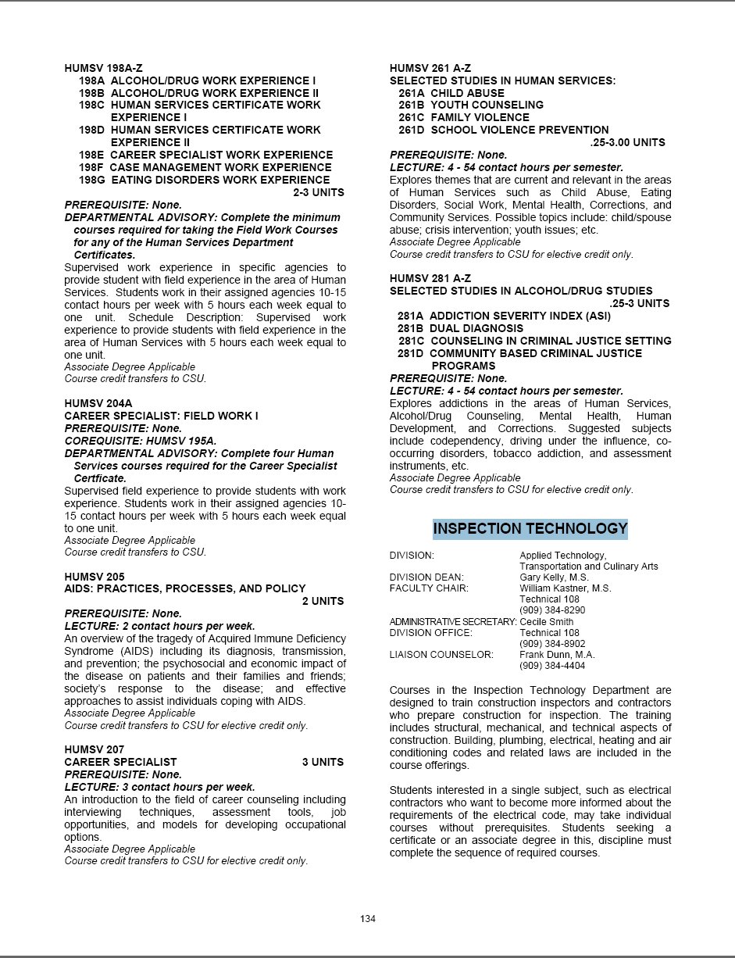
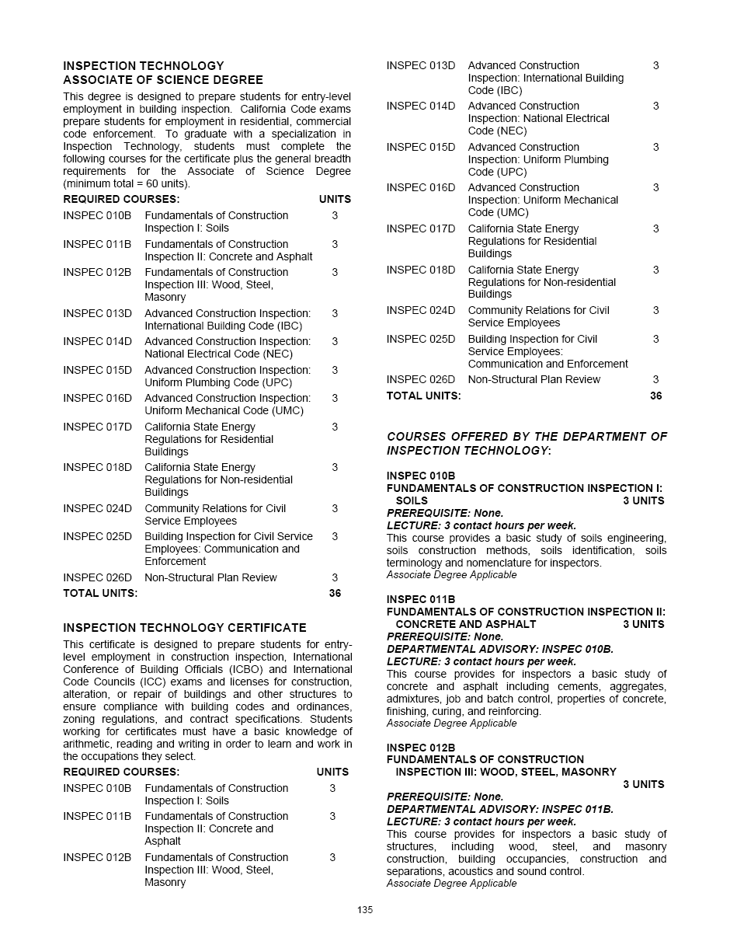
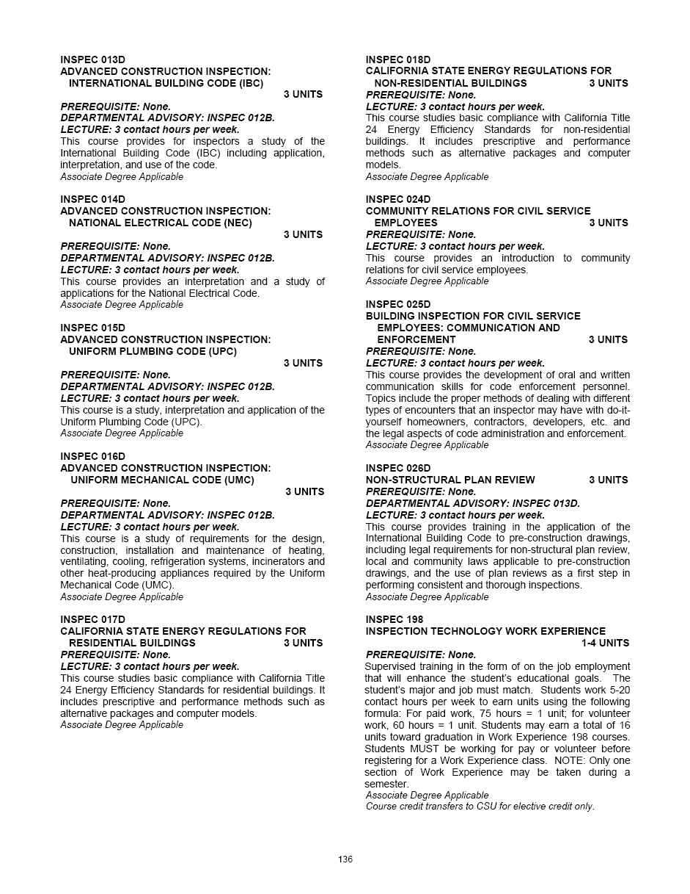

Which courses are no longer being offered? (Include Course # and Title of the Course)

Click here to enter text.
Click here to enter text.
Click here to enter text.
Click here to enter text.

Planning
What are the trends, external to the institution, impacting your student enrollment/service utilization? How will these trends impact program planning?
Click here to enter text.

Accomplishments and Strengths
Referencing the narratives in the EMP Summary, provide any additional data or new information regarding the accomplishments of the program, if applicable. In what way does your planning address accomplishments and strengths in the program?

Click here to enter text.

Weaknesses
Referencing the narratives in the EMP Summary, provide any additional data or new information regarding planning for the program. In what way does your planning address trends and weaknesses in the program?
Click here to enter text.

V. Questions Related to Strategic Initiative: Technology, Campus Climate and Partnerships.

Describe how your program has addressed the strategic initiatives of technology, campus climate and/or partnerships.
Click here to enter text.

